**CHAPTER 1: INTRODUCTION**

* 1. **PROJECT OVERVIEW**

The Virtual Library project aims to create a comprehensive online library system that provides users with easy access to digital and physical library resources, offering a convenient and efficient way to discover, borrow, and manage books, journals, and other materials. This digital platform will serve both library staff and patrons, enhancing the overall library experience.

In other words, our library provides features that can easily replace a librarian, who does thing manually. User can issue and return books. User have to return the book within 15 days, if he/she didn’t returned the book they have to pay fine for the same. Also, we have provided the features of Free PDF for limited books.

* 1. **OBJECTIVE**

The primary objectives of a Library Management System (LMS) are to efficiently and effectively manage library resources, streamline operations, enhance user experiences, and facilitate the overall functioning of the library. Here are the key objectives of a Library Management System:

* Maintain an organized and up-to-date catalog of all library resources, including books, journals, digital media, and other materials.
* Enable users to track their borrowing history, reserve items, and manage their account information.
* Automate the lending and return processes, including due date reminders and fine calculations.
* Focus on improving the overall user experience for patrons by offering convenient and user-friendly interfaces and services.
  1. **FLOW OF WEBSITE**

The main page of our website consists of navbar which contains, home page, Dashboard, Books and About-us section. Home page has some basic features of our website including Login/Sign-up. Dashboard provides user option for issuing and returning books. In the books section we have provided free pdf for different genres of books. And in about us the basic information of our website and team members.

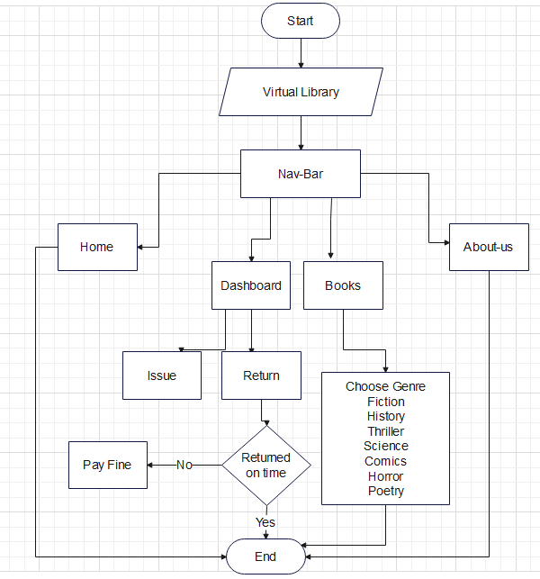

Fig. 1.1 Flowchart

* 1. **TOOLS AND TECHNOLOGIES**

The following tools and technologies are used:

* VS code
* Browser: Chrome
* HTML
* CSS
* Javascript

**CHAPTER 2: MODULE-1**

**2.1 Home page**

**2.1.1 Introduction**

The homepage of a virtual library is the gateway to its digital collection and services, serving as the initial point of interaction for users. It plays a crucial role in providing a user-friendly and informative experience. Here's a description of what you might find on the homepage of a virtual library. The home page of our website is the main page. It consists of navbar and further navbar consists login/signup, dashboard, about-us ,and book section . The library's logo and name are prominently displayed at the top of the homepage, providing a visual identity and making it clear to users where they are.

**2.1.2 Source Code**

<!DOCTYPE html>

<html lang="en">

<head>

<meta charset="UTF-8">

<meta name="viewport" content="width=device-width, initial-scale=1.0">

<title>Virtual Library</title>

</head>

<link rel="stylesheet" href="style.css">

<body>

<nav id="navbar">

<div id="logo">

<img src="https://www.logolynx.com/images/logolynx/aa/aa3993182ad88a047d21fbcc09b44d04.png" alt="Virtual Library

">

<div class="head">Virtual Library</div>

</div>

<ul>

<li class="item"><a href="#home" class="active">Home</a></li>

<li class="item"><a href="dashboard.html">Dashboard</a></li>

<li class="item"><a href="books.html">Books</a></li>

<li class="item"><a href="about.html">About-Us</a></li>

</ul>

<div class="right">

<button class="btn"><a href="login.html">Login</a></button>

<button class="btn"><a href="">Sign-Up</a></button>

</div>

</nav>

<div class="home">

<div class="heading">

<h1>Welcome to our Virtual Library</h1>

<p><i><b>~Efficiently manage your library resources~</b></i></p>

</div>

</div>

<div id="features">

<h1 class="h">Our Features</h1>

<div id="services">

<div class="box">

<img src="pictures/i1.jpeg" alt="">

<h2 class="h-secondary center">Access to vast collection of books</h2>

<p class="center">

Access a wide range of books and resorses from the comfort of your home

</p>

</div>

<div class="box">

<img src="pictures/i2.png" alt="">

<h2 class="h-secondary center">Convenient & User Friendly platform</h2>

<p class="center">

Easy to navigate interfaces for seamless user experience

</p>

</div>

<div class="box">

<img src="pictures/h2.jpg" alt="">

<h2 class="h-secondary center">Enables online borrowing & reading</h2>

<p class="center">

Borrow and read books online without physical copies

</p>

</div>

</div>

</body>

</html>

**2.1.3 Screenshots**

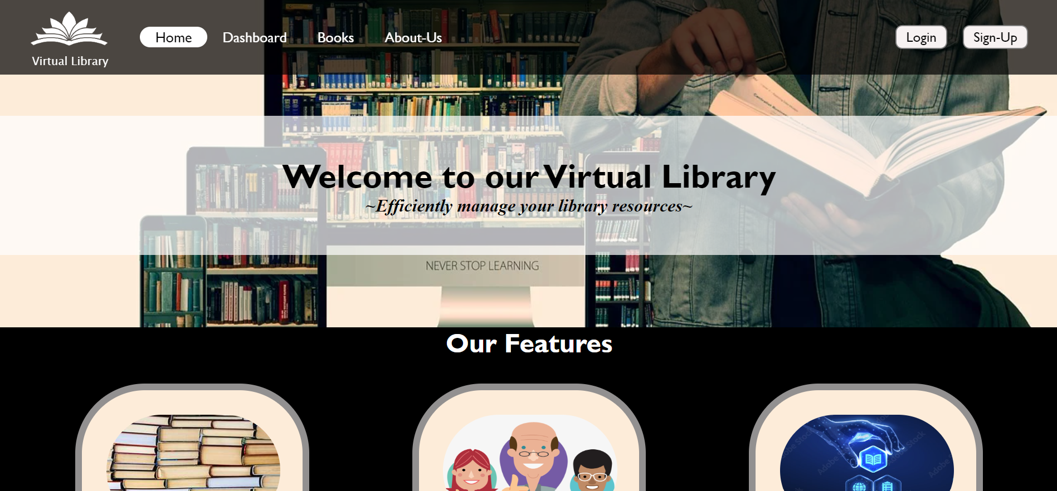

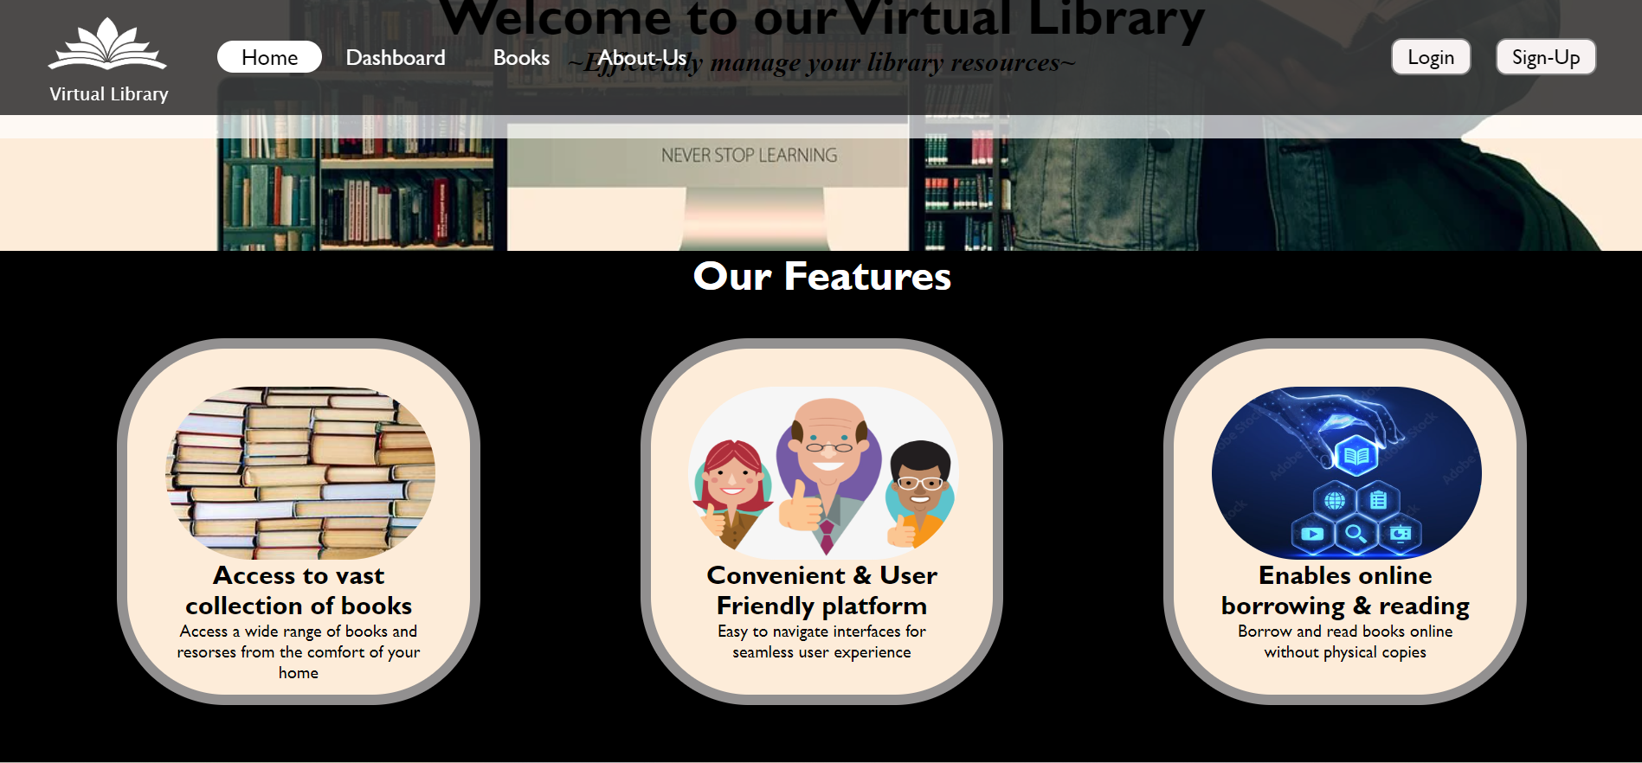

Fig. 2.1 Home Page

**2.2 Login/Sign-up**

In Login/Sign-up section provided at the right end of navbar provides authentication to user to put their email and password.

**2.2.1 Source Code**

<!DOCTYPE html>

<html lang="en">

<head>

<meta charset="UTF-8">

<meta name="viewport" content="width=device-width, initial-scale=1.0">

<title>Document</title>

</head>

<link rel="stylesheet" href="style.css">

<body>

<form class="frm">

<b><u>STUDENT LOGIN</u></b><br>

<div class="mb-3">

<label for="exampleInputEmail1" class="form-label">Email address: </label>

<input type="email" class="form-control" id="exampleInputEmail1" aria-describedby="emailHelp">

<div id="emailHelp" class="form-text"><br>(We'll never share your email with anyone else.)<br></div>

</div>

<div class="mb-3">

<label for="exampleInputPassword1" class="form-label"><br>Password: </label>

<input type="password" class="form-control" id="exampleInputPassword1">

</div><br>

<!-- <div class="mb-3 form-check"> -->

<!-- <input type="checkbox" class="form-check-input" id="exampleCheck1"> -->

<!-- <label class="form-check-label form-text" for="exampleCheck1">Check me out<br><br></label> -->

<!-- </div> -->

<button type="submit" class="btn btn-primary">Submit</button>

</form>

</body>

</html>

**2.1.2 Screenshots**

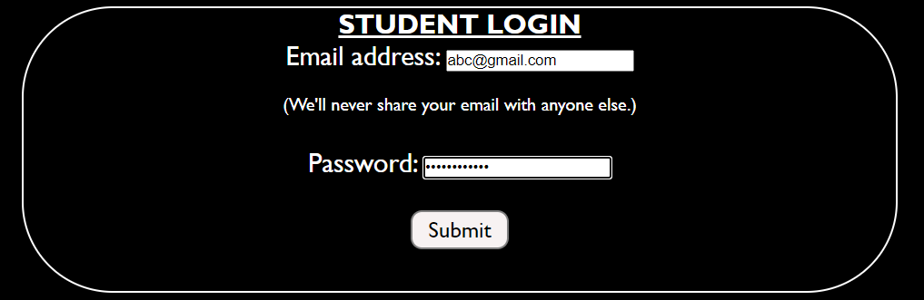

Fig. 2.2 Student Login

**CHAPTER 3: MODULE-2**

**3.1** **About Us**

**3.1.1****Content**

Virtual Library is cutting-edge library management system that streamlines the process of issuing and returning books. With our user friendly interface, patrons can easily browse books. Our system offers a pictorial presentation of books to issue & also provides a section for free books pdf. Virtual library is dedicated to providing the best library managemment experience to students.

**3.1.2 Source code**

<!DOCTYPE html>

<html lang="en">

<head>

<meta charset="UTF-8">

<meta name="viewport" content="width=device-width, initial-scale=1.0">

<title>Document</title>

</head>

<link rel="stylesheet" href="style.css">

<body>

<header>

<div class="bg">

<nav id="navbar">

<div id="logo">

<img src="https://www.logolynx.com/images/logolynx/aa/aa3993182ad88a047d21fbcc09b44d04.png" alt="Virtual Library

">

<div class="head">Virtual Library</div>

</div>

<ul>

<li class="item"><a href="lms.html">Home</a></li>

<li class="item"><a href="dashboard.html">Dashboard</a></li>

<li class="item"><a href="books.html">Books</a></li>

<li class="item"><a href="#" class="active">About-Us</a></li>

</ul>

</nav>

<!-- <h1 class="h">About-us</h1> -->

<div class="about">

<i> <b>About-Us:</b><br>Virtual Library is cutting-edge library management system that streamlines the process of issuing and returning books. With our user friendly interface, patrons can easily browse books. Our system offers a pictorial presentation of books to issue & also provides a section for free books pdf. Virtual library is dedicated to providing the best library managemment experience to students. </i>

</div>

</div>

</header>

<div class="he"><h1>~More About Us~</h1></div>

<div id="aboutbox">

<div class="abox">In the ever-expanding age of globalization, Virtual library offers the community with extensive materials and a comfortable environment. Since our foundation in 2023, we’re proud to be a positive resource for our users.</div>

<div class="abox" id="pic1"></div>

<div class="abox" id="pic2"></div>

<div class="abox">Our Library has transformed into a community hub that contributes much more than just free books. In future, its

's our goal to provide access to ideas, information, and experiences that support and enrich lives for people of all ages, abilities, and means. Keep browsing through our site to learn more & feel free to contact us.</div>

</div>

<div id="acon">

<div class="contact"><h1>MEET THE TEAM</h1><br><h4>Ishani Patel</h4><br>

<h4>Tanvi Patel</h4><br>

<h4>Vanshita Raisinghani</h4><br>

</div>

<div class="contact lft" ><h1>CONTACT US</h1><br>

<h4>E-Mail: abc@gmail.com<br>Phone: 123456789<br>(Feel free to contact us)</h4></div>

</div>

</body>

</html>

**3.1.3 Screenshots**

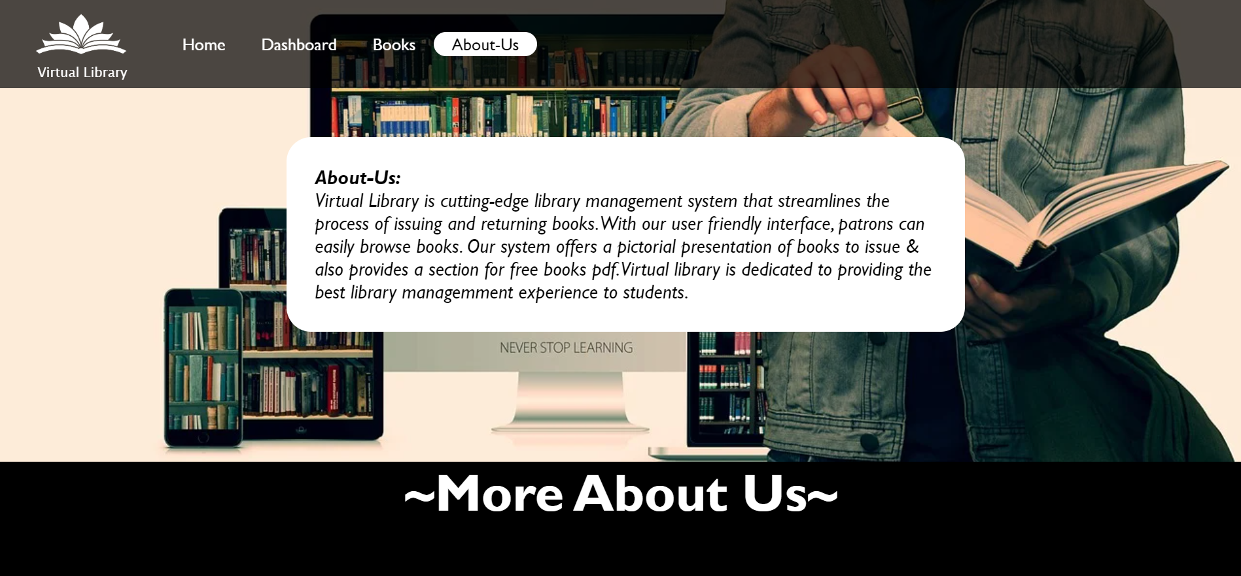

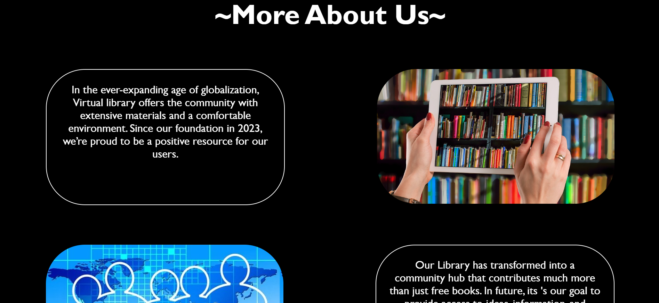

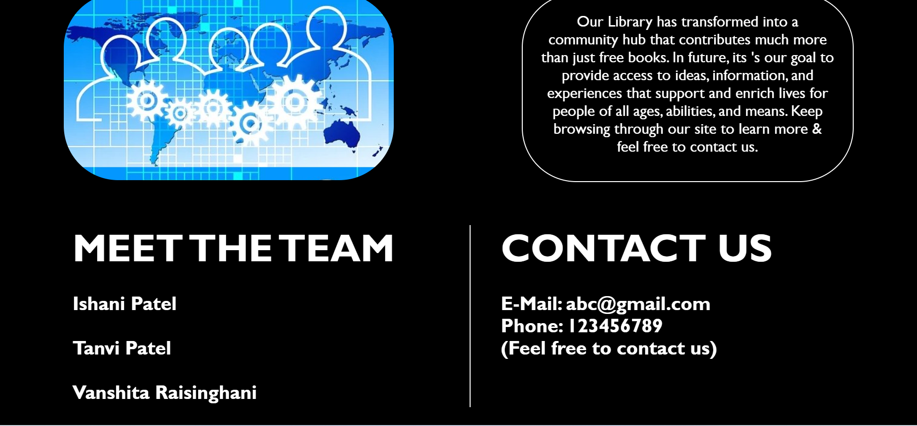

Fig. 3.1 About Us

**CHAPTER 4: MODULE-3**

**4.1****Books**

**4.1.1 Genre**

In this book section we have provided different types of genres so individual can choose according to their interest. Further, we have provided different book for individual genres and user can access simply by clicking on it.

We have provided 8 different genres:

* Fiction
* Comics
* Science
* Poetry
* History
* Biography
* Horror
* Thriller

**4.1.1 Source Code**

**Books Webpage**

<!DOCTYPE html>

<html lang="en">

<head>

<meta charset="UTF-8">

<meta name="viewport" content="width=device-width, initial-scale=1.0">

<title>Document</title>

</head>

<link rel="stylesheet" href="style.css">

<body>

<nav id="navbar">

<div id="logo">

<img src="https://www.logolynx.com/images/logolynx/aa/aa3993182ad88a047d21fbcc09b44d04.png" alt="Virtual Library

">

<div class="head">Virtual Library</div>

</div>

<ul>

<li class="item"><a href="lms.html">Home</a></li>

<li class="item"><a href="dashboard.html">Dashboard</a></li>

<li class="item"><a href="#" class="active">Books</a></li>

<li class="item"><a href="about.html" >About-Us</a></li>

</ul>

</nav>

<div id="features">

<h1 class="h">Choose Genre</h1>

<div id="genre">

<div class="box1">

<img src="pictures/fiction.jpeg" alt="">

<h2 class="h-secondary center"><a href="books1.html">Fiction</a></h2>

</div>

<div class="box1">

<img src="pictures/history.jpeg" alt="">

<h2 class="h-secondary center"><a href="books1.html">History</a></h2>

</div>

<div class="box1">

<img src="pictures/thriller.jpg" alt="">

<h2 class="h-secondary center"><a href="books1.html">Thriller</a></h2>

</div>

<div class="box1">

<img src="pictures/science.jpeg" alt="">

<h2 class="h-secondary center"><a href="books1.html">Science</a></h2>

</div>

<div class="box1">

<img src="pictures/comic.jpg" alt="">

<h2 class="h-secondary center"><a href="books1.html">Comics</a></h2>

</div>

<div class="box1">

<img src="pictures/horror.jpg" alt="">

<h2 class="h-secondary center"><a href="books1.html">Horror</a></h2>

</div>

<div class="box1">

<img src="pictures/bio.jpeg" alt="">

<h2 class="h-secondary center"><a href="books1.html">Biography</a></h2>

</div>

<div class="box1">

<img src="pictures/poetry.jpeg" alt="">

<h2 class="h-secondary center"><a href="books1.html">Poetry</a></h2>

</div>

</div>

</body>

</html>

**4.1.2 Screenshots**

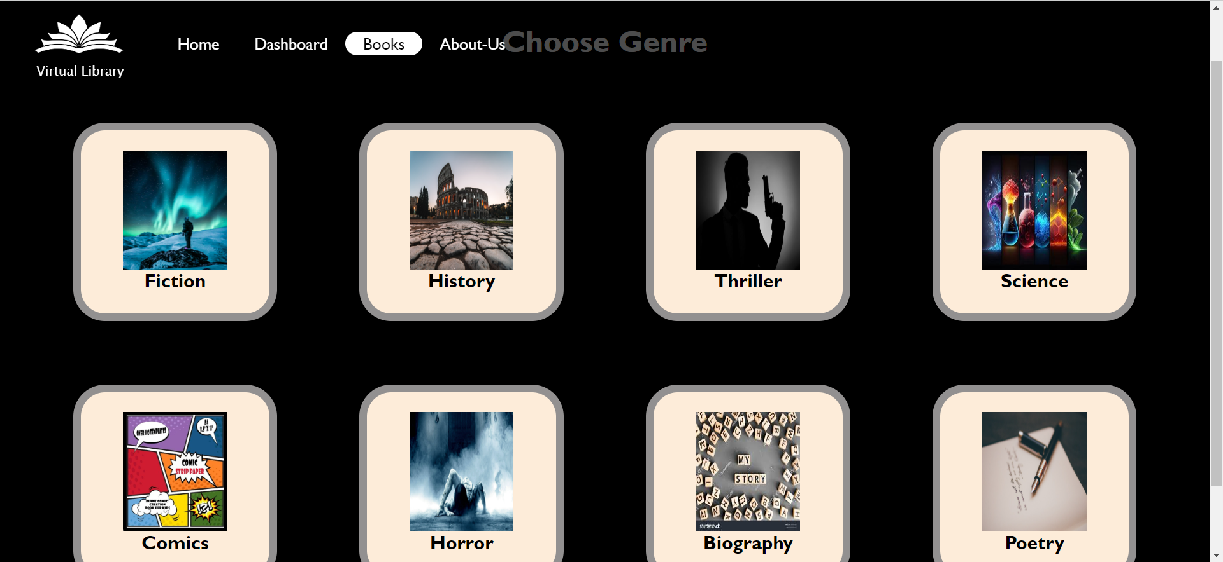

**4.1.1 Source Code**

**Choose books webpage**

. <!DOCTYPE html>

<html lang="en">

<head>

<meta charset="UTF-8">

<meta name="viewport" content="width=device-width, initial-scale=1.0">

<title>Fiction</title>

<link rel="stylesheet" href="style.css">

</head>

<body>

<nav id="navbar">

<div id="logo">

<img src="https://www.logolynx.com/images/logolynx/aa/aa3993182ad88a047d21fbcc09b44d04.png" alt="Virtual Library

">

<div class="head">Virtual Library</div>

</div>

<ul>

<li class="item"><a href="lms.html">Home</a></li>

<li class="item"><a href="dashboard.html">Dashboard</a></li>

<li class="item"><a href="books.html" class="active">Books</a></li>

<li class="item"><a href="about.html" >About-Us</a></li>

</ul>

</nav>

<div id="features">

<h1 class="h">Fiction</h1>

<div id="book1">

<div class="box2">

<a href="19thwife.pdf"><img src="https://3.bp.blogspot.com/_56AFlvjk9Qc/TGxs0Oz-djI/AAAAAAAABbA/WiHL0a32ARY/s1600/19th+wife.jpg" alt=""></a>

<h2 class="h-secondary center"><a href="19thwife.pdf">19th-Wife</a></h2>

</div>

<div class="box2">

<img src="https://sp.yimg.com/ib/th?id=OPHS.ReUe%2b3AcLKX6Vg474C474&o=5&pid=21.1&w=174&h=174" alt="">

<h2 class="h-secondary center">Surviving home</h2>

</div>

<div class="box2">

<img src="https://s.yimg.com/fz/api/res/1.2/eI1yORRoD9T34YlUQsi.JQ--~C/YXBwaWQ9c3JjaGRkO2ZpPWZpdDtoPTI2MDtxPTgwO3c9MTcy/https://s.yimg.com/zb/imgv1/5348b358-c3fd-339f-b356-f55394d04132/t_500x300" alt="">

<h2 class="h-secondary center">Catch-22</h2>

</div>

<div class="box2">

<a href="FireDance.pdf">

<img src="https://bloximages.newyork1.vip.townnews.com/postandcourier.com/content/tncms/assets/v3/editorial/4/f2/4f24a2e1-f2a1-5264-8240-c4aaca50607a/5acb824c75eec.image.jpg" alt="">

<h2 class="h-secondary center">Fire Dance</h2></a>

</div>

<div class="box2">

<img src="https://99designs-blog.imgix.net/blog/wp-content/uploads/2017/02/attachment_74814572-e1486420174369.jpg?auto=format&q=60&fit=max&w=930" alt="">

<h2 class="h-secondary center">Enceladus</h2>

</div>

<div class="box2">

<img src="https://tse4.mm.bing.net/th?id=OIP.TYVH6s-Rb0AhvAwyGmCc9gHaKp&pid=Api&P=0&h=220" alt="">

<h2 class="h-secondary center">Repeat</h2>

</div>

<div class="box2">

<img src="https://tse2.explicit.bing.net/th?id=OIP.Vp41uncxlZ6VtQxoBjaHJgHaKb&pid=Api&P=0&h=220" alt="">

<h2 class="h-secondary center">Star</h2>

</div>

<div class="box2">

<img src="https://images.squarespace-cdn.com/content/v1/5202d1b3e4b099a0812c51a3/1530392466668-Q70KDYOKHDMVXFD49BNA/ke17ZwdGBToddI8pDm48kFjiq_0Ek1NItql1dLmsgNNZw-zPPgdn4jUwVcJE1ZvWEtT5uBSRWt4vQZAgTJucoTqqXjS3CfNDSuuf31e0tVGQiKALUW-YxfFfP4p0PvHcTla7NnOOvQwSGt9YLKLGBhEym7bB5Y8EAaW-uC2HxJQ/The-Red-Citadel.jpg" alt="">

<h2 class="h-secondary center">Citadel</h2>

</div>

<div class="box2">

<img src="https://www.ereads.com/wp-content/uploads/2020/07/Best-Science-Fiction-Comic-Books.jpg" alt="">

<h2 class="h-secondary center">Galaxy</h2>

</div>

<div class="box2">

<img src="https://qph.fs.quoracdn.net/main-qimg-48eef84f36a51492a38ab183f0dc9728" alt="">

<h2 class="h-secondary center">Kemlo</h2>

</div>

</div>

</body>

</html>

**4.1.2 Screenshots**



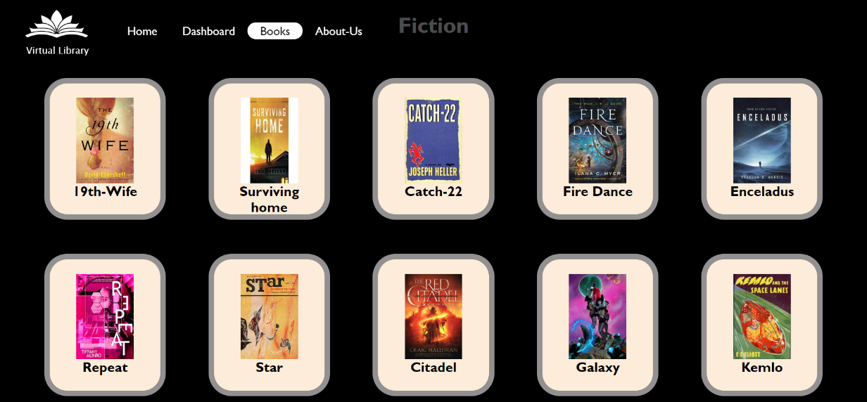

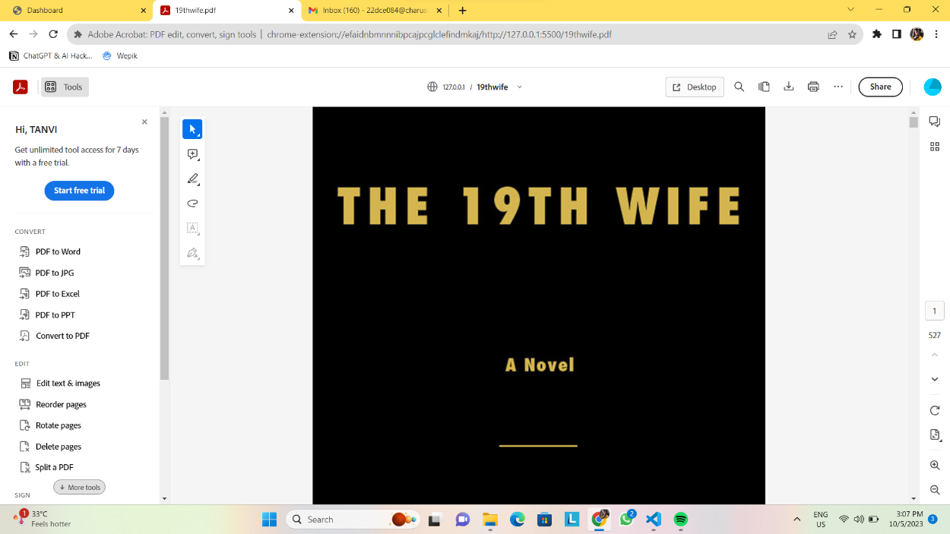

Fig. 4.1 Books & pdf

**CHAPTER 5: MODULE-4**

**5.1-Dashboard**

**5.1.1**

Dashboard contain various features like issue , return , pay fine (If returned late). It also provide information like stack number of books , book id and number of books left. User can issue only 5 books at a time .

**5.1.2 Source Code**

<!DOCTYPE html>

<html lang="en">

<head>

<meta charset="UTF-8">

<meta name="viewport" content="width=device-width, initial-scale=1.0">

<title>Dashboard</title>

<link rel="stylesheet" href="style.css">

</head>

<body>

<nav id="navbar">

<div id="logo">

<img src="https://www.logolynx.com/images/logolynx/aa/aa3993182ad88a047d21fbcc09b44d04.png" alt="Virtual Library

">

<div class="head">Virtual Library</div>

</div>

<ul>

<li class="item"><a href="lms.html">Home</a></li>

<li class="item"><a href="#" class="active">Dashboard</a></li>

<li class="item"><a href="books.html">Books</a></li>

<li class="item"><a href="about.html">About-Us</a></li>

</ul>

<div class="right">

<button class="btn"><a href="login.html">Login</a></button>

<button class="btn"><a href="">Sign-Up</a></button>

</div>

</nav>

<div class="abc">

<div class="c1" id="b-1"><b class="font">ISSUE</b><br>*(You can only issue 5 books at a time)<br><br>

<div class="content" id="p1">Books Issued: <spam id="counter">0</spam><br><br>

</div>

</div>

<div class="c1" id="b-2"><b class="font">RETURN</b><br>

*(Return within 15 days)<br><br>

<div class="content">Books not returned yet: <spam id="counter1">0</spam></div>

</div>

<div class="c1" id="b-3"><b class="font">PAY FINE</b><br>*(If returned late you must pay fine)<br><br>

You can pay fine offline<br>

OR Online Payment

</div>

</div>

<table class="table">

<tr>

<th>Book ID</th>

<th>Book Name</th>

<th>Author</th>

<th>Books Left</th>

<th>Stack No.</th>

<th>Issue</th>

<th>Return</th>

</tr>

<tr class="odd">

<td>2SF035</td>

<td>Harrypotter and the order of phoenix</td>

<td>JK Rowling</td>

<td class="numBooks">3</td>

<td>7</td>

<td>

<button class="tbtn b1" id="bt1">Issue</button>

</td>

<td>

<button class="tbtn2 b1" id="btt1">Return</button>

</td>

</tr>

<tr class="even">

<td>2BA053</td>

<td>The Alchemist</td>

<td>Paulo Coelho</td>

<td class="numBooks">8</td>

<td>1</td>

<td>

<button class="tbtn b2" id="bt2">Issue</button>

</td>

<td>

<button class="tbtn2 b2" id="btt2">Return</button>

</td>

</tr>

<tr class="odd">

<td>2DC071</td>

<td>The 19th wife</td>

<td>JB Rowling</td>

<td class="numBooks">5</td>

<td>6</td>

<td>

<button class="tbtn b3" id="bt3">Issue</button>

</td>

<td>

<button class="tbtn2 b3" id="btt3">Return</button>

</td>

</tr>

<tr class="even">

<td>2CE98</td>

<td>Galaxy</td>

<td>khp D'souza</td>

<td class="numBooks">2</td>

<td>1</td>

<td>

<button class="tbtn b4" id="bt4">Issue</button>

</td>

<td>

<button class="tbtn2 b4" id="btt4">Return</button>

</td>

</tr>

<tr class="odd">

<td>2IT84</td>

<td>Conjouring</td>

<td>Dhruvi Soni</td>

<td class="numBooks">0</td>

<td>3</td>

<td>

<button class="tbtn b5" id="bt5">Issue</button>

</td>

<td>

<button class="tbtn2 b5" id="btt5">Return</button>

</td>

</tr>

<tr class="even">

<td>2SC117</td>

<td>The Mocking Bird</td>

<td>Eminem</td>

<td>3</td>

<td>1</td>

<td>

<button class="tbtn">Issue</button>

</td>

<td>

<button class="tbtn2">Return</button>

</td>

</tr>

<tr class="odd">

<td>2OS065</td>

<td>WRECK</td>

<td>SJ SHAH</td>

<td>50</td>

<td>26</td>

<td>

<button class="tbtn">Issue</button>

</td>

<td>

<button class="tbtn2">Return</button>

</td>

</tr>

<tr class="even">

<td>2CE029</td>

<td>ALONE</td>

<td>BP James</td>

<td>3</td>

<td>9</td>

<td>

<button class="tbtn">Issue</button>

</td>

<td>

<button class="tbtn2">Return</button>

</td>

</tr>

<tr class="odd">

<td>2IT66</td>

<td>BARBIE</td>

<td>DG Snake</td>

<td>5</td>

<td>4</td>

<td>

<button class="tbtn">Issue</button>

</td>

<td>

<button class="tbtn2">Return</button>

</td>

</tr>

<tr class="even">

<td>2KJ32</td>

<td>Catch-22</td>

<td>RV Patel</td>

<td>0</td>

<td>1</td>

<td>

<button class="tbtn">Issue</button>

</td>

<td>

<button class="tbtn2">Return</button>

</td>

</tr>

<tr class="odd">

<td>2CB32</td>

<td>Fault in our stars</td>

<td>VR Kaka</td>

<td>3</td>

<td>23</td>

<td>

<button class="tbtn">Issue</button>

</td>

<td>

<button class="tbtn2">Return</button>

</td>

</tr>

<tr class="even">

<td>2BN33</td>

<td>KITE RUNNER</td>

<td>Tp Williamson's</td>

<td>5</td>

<td>6</td>

<td>

<button class="tbtn">Issue</button>

</td>

<td>

<button class="tbtn2">Return</button>

</td>

</tr>

<tr class="odd">

<td>2CE23</td>

<td>Tom Clancy</td>

<td>Ip Ben</td>

<td>0</td>

<td>1</td>

<td>

<button class="tbtn">Issue</button>

</td>

<td>

<button class="tbtn2">Return</button>

</td>

</tr>

<tr class="even">

<td>2DC12</td>

<td>Just Mercy</td>

<td>NP Won</td>

<td>9</td>

<td>14</td>

<td>

<button class="tbtn">Issue</button>

</td>

<td>

<button class="tbtn2">Return</button>

</td>

</tr>

<tr class="odd">

<td>3RE09</td>

<td>African Buva</td>

<td>Dhruvi Stifen</td>

<td>6</td>

<td>4</td>

<td>

<button class="tbtn">Issue</button>

</td>

<td>

<button class="tbtn2">Return</button>

</td>

</tr>

<tr class="even">

<td>5SV67</td>

<td>Stephen King</td>

<td>Unji L</td>

<td>50</td>

<td>100</td>

<td>

<button class="tbtn">Issue</button>

</td>

<td>

<button class="tbtn2">Return</button>

</td>

</tr>

<tr class="odd">

<td>2SE87</td>

<td>Dairy of Anne Frank </td>

<td>Anne Frank</td>

<td>4</td>

<td>15</td>

<td>

<button class="tbtn">Issue</button>

</td>

<td>

<button class="tbtn2">Return</button>

</td>

</tr>

<tr class="even">

<td>8HE03</td>

<td>3 days to live</td>

<td>Hellen kellar</td>

<td>1</td>

<td>8</td>

<td>

<button class="tbtn">Issue</button>

</td>

<td>

<button class="tbtn2">Return</button>

</td>

</tr>

<tr class="odd">

<td>0JS34</td>

<td>Azadi ki ladai</td>

<td>Ghandhi bapu</td>

<td>10</td>

<td>36</td>

<td>

<button class="tbtn">Issue</button>

</td>

<td>

<button class="tbtn2">Return</button>

</td>

</tr>

<tr class="even">

<td>3FR56</td>

<td>Street Food</td>

<td>Shangai</td>

<td>0</td>

<td>1</td>

<td>

<button class="tbtn">Issue</button>

</td>

<td>

<button class="tbtn2">Return</button>

</td>

</tr>

</table>

<script src="dashboard.js" charset="UTF-8"></script>

<!-- <script src="db.js" charset="UTF-8"></script> -->

</body>

</html>

**Jasvscript code:**

var btnlen=document.querySelectorAll(".tbtn").length;

var count=0;

const counter = document.getElementById("counter");

const counter1 = document.getElementById("counter1");

for(var i=0;i<btnlen; i++){

document.querySelectorAll(".tbtn")[i].addEventListener("click", function(){

if(count<=4){

// if(document.querySelectorAll(".numBooks")[i].innerHTML>0)

{

var a=document.querySelectorAll(".numBooks")[i+1].innerHTML;

const s=document.querySelectorAll(".numBooks")[i+1];

s.textContent=a-1;

count++;

counter.textContent = count;

counter1.textContent=count;

}

// else

{

// alert("hello");

}

}

else{

alert("You Cant choose More than 5 books!!");

}

});

}

**5.1.2 Screenshots**

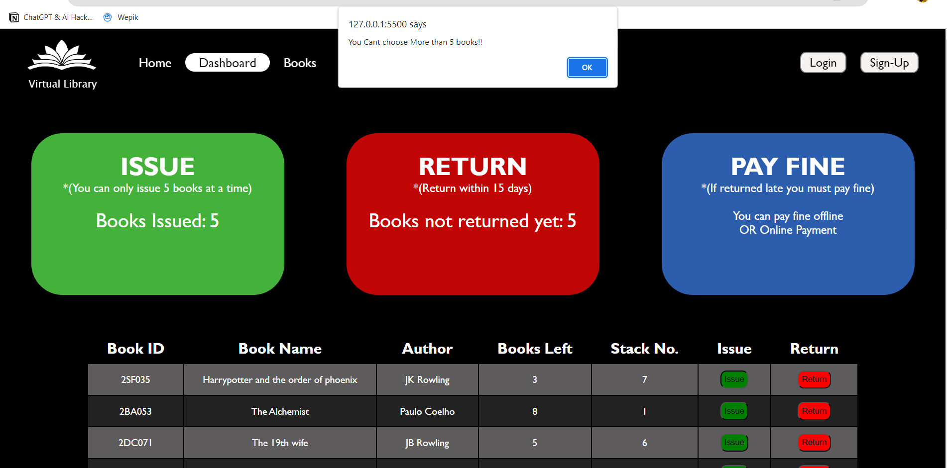

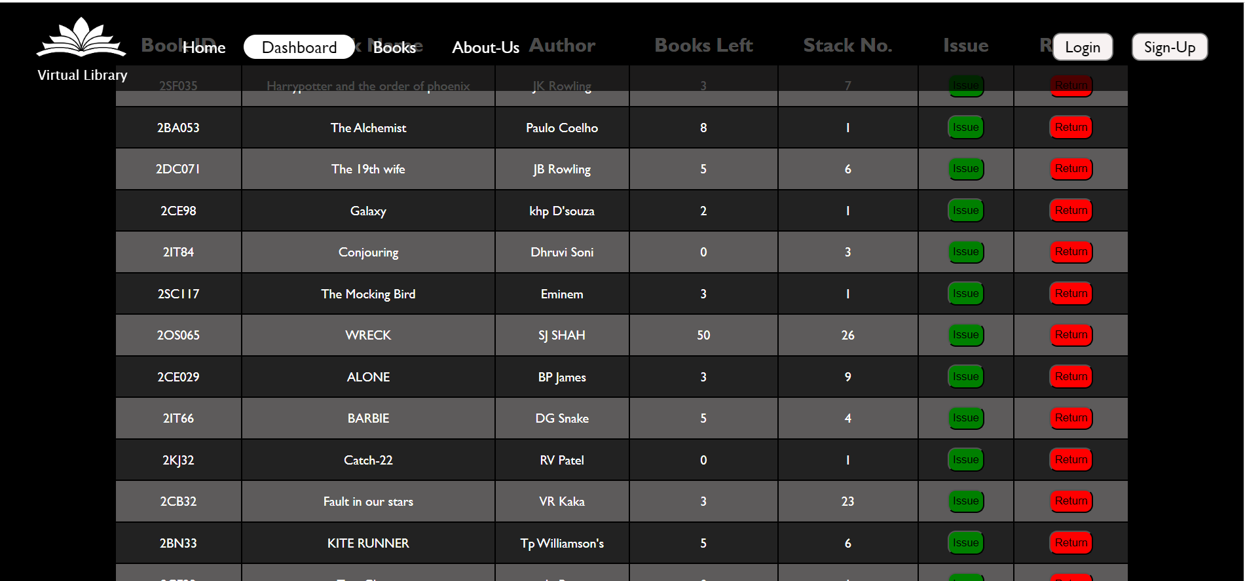

Fig 5.1 Dashboard

**CHAPTER 6: CONCLUSION**

**6.1.1 Future work**

There are some extra features that can be added afterwards in future to our website

Such as:

1. Adding Social book clubs.

2. Making this website admin based also.

3. Improving accessibility options for people with disability.

But for now we have limited time so we are not approaching these features for now.

**6.1.2 Summary**

An online virtual library system streamlines book issuing and returning processes digitally, offering users the convenience of managing their library materials online. It enables users to borrow and return books electronically, eliminating the need for physical visits. Additionally, the system provides free access to limited books in PDF format, enhancing accessibility to valuable resources. This blend of digital efficiency and free PDF offerings makes the virtual library a versatile and user-friendly platform, catering to the modern reader's needs for both convenience and access to knowledge.

**6.1.3 References**

* <https://www.w3schools.com/html/>
* <https://www.w3schools.com/css/>
* <https://www.w3schools.com/Js/>
* <https://www.w3schools.com/bootstrap/>
* [https://www.youtube.Apnacollage//CSS](https://www.youtube.com/watch?v=ESnrn1kAD4E)
* [https://www.youtube.com/Codewith harry//html,css,js](https://www.youtube.com/watch?v=6mbwJ2xhgzM&list=PLu0W_9lII9agiCUZYRsvtGTXdxkzPyItg)